SPRINT-4

CODE:

<!DOCTYPE html>

<html lang="en">

<head>

<meta charset="UTF-8">

<meta name="viewport" content="width=device-width, initial-scale=1.0">

<link rel="stylesheet" href="/FIREOAUTH.css">

<link rel="stylesheet" href="https://cdnjs.cloudflare.com/ajax/libs/nprogress/0.2.0/n progress.min.css">

<link rel="shortcut icon" href="https://raw.githubusercontent.com/tharunoptimus- pd/firepwa/main/favicon.ico?token=GHSAT0AAAAAABR46 HVJ5M5L3QGFRZRQXOISYUJUWAA" type="image/x-

icon">

<style> html, body {

height: 100%;

margin: 0;

font-family: -apple-system, BlinkMacSystemFont,

"Segoe UI", Roboto, Oxygen,Ubuntu, Cantarell, "Open Sans", "Helvetica Neue",

sans-serif;

font-weight: 300;

}

a {

text-decoration: none; color: #007bff;

font-weight: 500; font-size: 1.2rem;

}

h3 {

font-size: 1.4rem;

}

h3, h4 { margin: 0;

padding: 0.3rem 0;

}

.wrapper { display: flex;

flex-direction: column; align-items: center; justify-content: center; height: 100%;

text-align: center;

}

.oneClickSignin { padding: 0.5rem;

border: 1px solid #44444444; border-radius: 5px;

box-shadow: 0 0 3px 0px #44444444;

opacity: 0.2;

pointer-events: none;

}

.qrcode { opacity: 0.1;

}

.learnAboutFire { padding-top: 1.25em;

}

.qrHolder { display: none; margin-top: 3rem;

}

.qrContainer { align-items: center; display: flex;

justify-content: center; padding: 8px;

margin: 2rem auto;

box-shadow: 0 0px 6px 1px rgb(0 0 0 / 16%); border: 1px solid #44444444;

border-radius: 6px;

width: 200px; height: 200px;

}

</style>

<title>Fire OAuth</title>

<script>

if (window.location.hostname !== "localhost") { if (location.protocol !== "https:") { location.replace(

`https:${location.href.substring( location.protocol.length

)}`

)

}

}

</script></head>

<body>

<div class="wrapper">

<h3 class="pageTitle">Login with SAFETY</h3>

<div class="qrAuthorize">

<h4 class="subTitle">Scan QR from your Fire OAuth App?</h4>

<div class="qrContainer">

<canvas id="qr-code" class="qrcode"></canvas>

</div>

</div>

<div class="oneClickSignin">

<h4>Have Fire PWA on this device?</h4>

<a target="_blank" id="authorizeOverLink" href="https://firepwa.netlify.app/authorize?sessionId" rel="noopener">Click to Authorize ? </a>

</div>

<div class="learnAboutFire">

<a target="_blank"

href="https://fireoauth.netlify.app" rel="noopener">Learn More about SAFETY</a>

</div>

</div>

<script src="https://cdnjs.cloudflare.com/ajax/libs/nprogress/0.2.0/n progress.min.js"></script>

<script src="https://cdnjs.cloudflare.com/ajax/libs/qrious/4.0.2/qriou

s.min.js"></script>

<script src="https://cdnjs.cloudflare.com/ajax/libs/socket.io/4.2.0/soc ket.io.js"></script>

<script>const FIRE_API_KEY = "635b790a3bcc6b59c4b772d0" const FIRE_ENDPOINT = "https://fire.adaptable.app/api/apis/generate"

const CHANNEL_NAME = "fireOAuthChannel" const broadCastingChannel = new BroadcastChannel(CHANNEL_NAME)

const FIRE_SERVER_SOCKET_ENDPOINT =

"https://fire.adaptable.app"

let socket = io(FIRE_SERVER_SOCKET_ENDPOINT) let qr

let qrcode = document.querySelector(".qrcode") let oneClickSignin = document.querySelector(".oneClickSignin")

let pageTitle = document.querySelector(".pageTitle") let subTitle = document.querySelector(".subTitle") function setOpacity(opacity) { oneClickSignin.style.opacity = opacity oneClickSignin.style.pointerEvents = opacity === "1" ? "auto" : "none"

qrcode.style.opacity = opacity

}

async function getSessionID() { let response

try {

response = await fetch(`${FIRE_ENDPOINT}/${FIRE_API_KEY}`, { method: "GET",

headers: {

"Content-Type": "application/json",

}

})

} catch (error) { console.log(error) return null

}let data = await response.json()

let { sessionId, chatRoomId } = data return { sessionId, chatRoomId }

}

function generateQR(value) {

(qr = new QRious({

element: document.getElementById("qr-code"), size: 200,

level: 'M', value: value,

}))

}

function changeHREF ({sessionId, chatRoomId}) { let firePwaUrlHostname = "https://firepwa.netlify.app"

let originURL = encodeURIComponent(window.location.origin) let url =

`${firePwaUrlHostname}/authorize.html?sessionId=${session Id}&chatRoomId=${chatRoomId}&url=${originURL}`

let a = document.getElementById("authorizeOverLink") a.href = url

}

async function fire() { NProgress.set(0.4)

let { sessionId, chatRoomId } = await getSessionID() if(sessionId === undefined || chatRoomId ===

undefined || sessionId === null || chatRoomId === null) { pageTitle.innerHTML = "Something went wrong

?"subTitle.innerHTML = "Please try again later ?" return

}

setOpacity("1") NProgress.done() let data = { sessionId,

url: encodeURIComponent(window.location.origin)

}

data = JSON.stringify(data) generateQR(data) changeHREF({sessionId, chatRoomId}) socket.emit("join room", sessionId)

}

fire()

socket.on("trusted token", (token) => { let data = {}

data.success = true

data.token = token broadCastingChannel.postMessage(data) window.close()

})

</script>

</body>

</html>

OUTPUT:

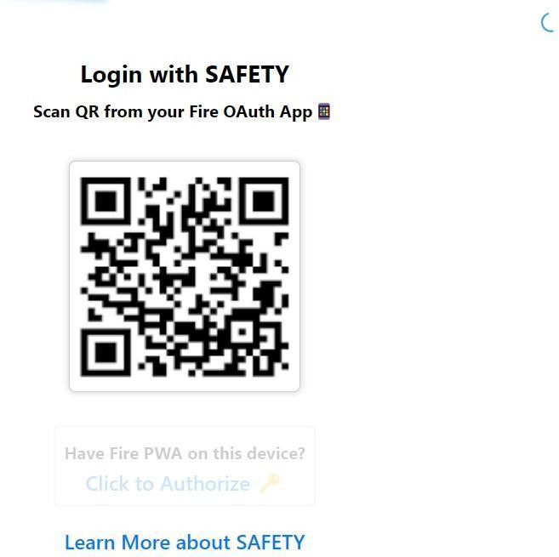

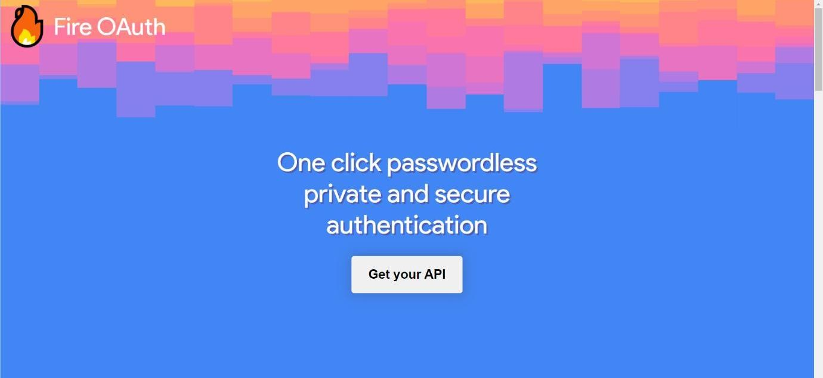

GEOFENCE NODE

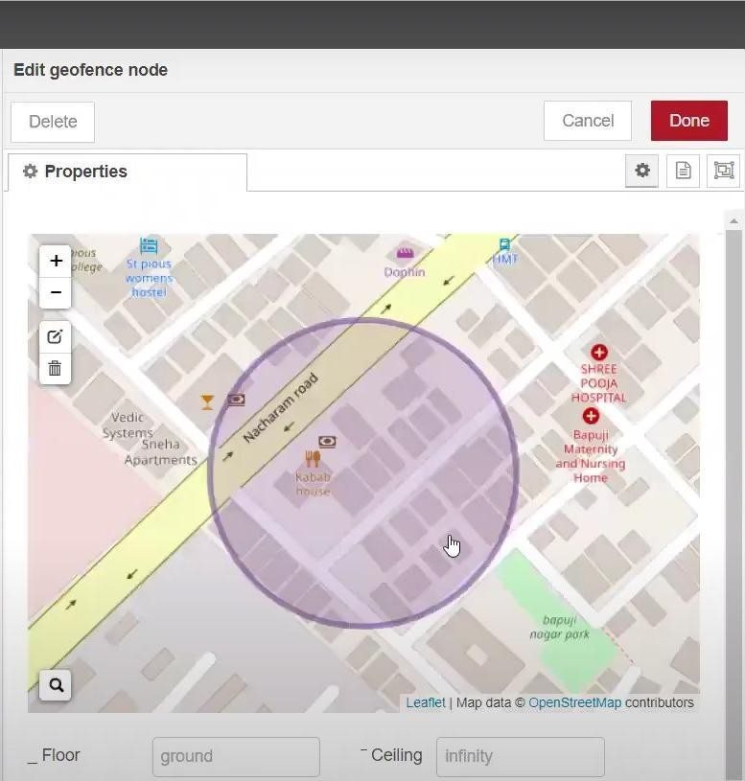

**LOCATION:**

After running the script, the web UI shows “Child is not in the particular area

